
Rev.0.0
[25/12/2025]

Ras El Hekma International Airport
“Storm Drainage Network “

Technical and Commercial Proposal

Prepared for
MODON

by
Infrastructure Department
AIEcon Consultants LLC

Document Development History
Revision | Date | Author | Checked by | Approved By
0.0 | 25 December  2025 | AIEcon | A.H | A.H
0.1

Table of Contents
Document Development History 2
List of Tables 4
List of Figures 4
1. Introduction 5
1.1 Project Overview 6
2. AIEcon Overview 7
2.1 Who are we 7
2.2 AIEcon’s Vision 7
2.3 AIEcon’s Branches 7
2.4 AIEcon’s Experience 8
2.5 AIEcon’s Partners 10
3. Project Scope: 11
4. BIM Methodology (Optional) 13
5. Financial Proposal 14

List of Tables
Table 1: AIEcon’s Consultation Services 9

List of Figures
Figure 1: Project Masterplan 6
Figure 2: Location of AIEcon offices 8
Figure 3: AIEcon’s Footprint 8
Figure 4 AIEcon’s Partners 10

Introduction
NACO has been contracted to undertake the role as design consultant to develop a design for the new Ras El Hekma International Airport (REH). The design consists of the facilities and infrastructure within the airport premises, following the masterplan phase. The design under this Contract will be developed for Modon International Real Estate as a 30% Concept Design. The design will be detailed to a 100% Detailed Design under a separate contract also under Modon.
This technical and financial proposal is submitted by AIEcon’s team, a seasoned civil engineering consultancy firm with over 35 years of practical experience in the field. We approach this project with a full-service mindset, applying the international and local standards, and delivering comprehensive Civil 3D and AutoCAD-based design documentation tailored to the industrial sector.

1.1 Project Overview
The site selected for the development of the airport is situated approximately 25km inland from the site of the development of the Ras El Hekma megaproject, in the Matrouh Governorate, in the northwestern part of Egypt. The site location in relation to Alexandria is shown in below figure.
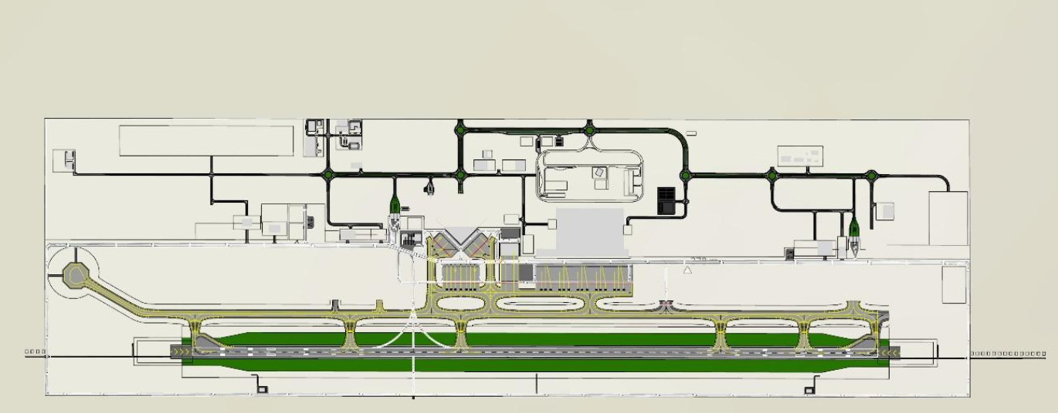
Figure 1: Project Masterplan

AIEcon Overview

2.1 Who are we
With over 35 years of experience, AIECons excels in civil engineering, specializing in flood protection, storm drainage, groundwater management, marine and coastal works, and water supply systems. With three branches worldwide, the company envisions establishing a leading, innovative organization excelling in a competitive environment, leveraging our team's expertise and skills to serve the community and enhance engineering consultancy standards.

2.2 AIEcon’s Vision
Our vision is establishing a progressive and well-known reputable organization in a competitive work environment where the members’ professional background, experience, skills and capabilities could be used, to serve the community in an ethical way that will help improve the consultancy field to higher respectable levels. By combining our understanding of the locals with our global expertise, we provide innovative solutions with the best quality for our communities, as we know that quality, value and adaptation to the environment are the keys of success.

2.3 AIEcon’s Branches
AIEcon operates through a network of regional and international branches, ensuring proximity to clients and projects. We have established offices in the USA, KSA (with a branch in Jeddah), and Cairo, Egypt. The figure (fig.3) shows the location of AIEcon offices, with our main headquarters located in Cairo, Egypt.
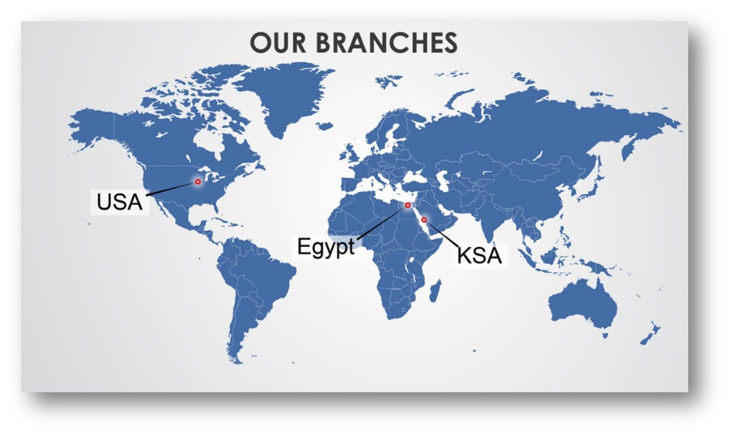
Figure 2: Location of AIEcon offices

2.4 AIEcon’s Experience
AIEcon L.L.C has successfully delivered over 500 projects during 35 years of operations across the Middle East, Africa, and Asia. Backed by a team of 60 highly qualified staff holding PhDs and Master’s degrees, we bring together academic knowledge and hands-on field experience in around 20 countries. The figure (Fig. 4) illustrates the footprint of AIEcon in different countries.
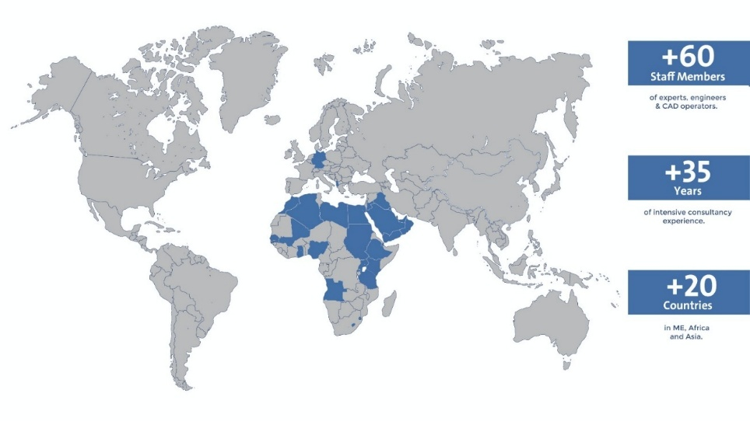
Figure 3: AIEcon’s Footprint
The main fields are shown in the below table (T.1). More details on AIEcon’s projects and expertise are available on the company website https://aieconsultant.com.
Table 1: AIEcon’s Consultation Services
Hydrological Studies and Flood Protection
Dam Engineering Studies
Marine Design and Engineering Solutions
Groundwater Management
Infrastructure Design
Roads, Airports and Railways Engineering
GIS and BIM Design
Surveying and Construction Supervision

2.5 AIEcon’s Partners
AIEcon collaborates with a network of trusted partners, both regionally and internationally, to deliver integrated and high-quality engineering solutions. Our partnerships strengthen our ability to address complex infrastructure challenges and provide added value to our clients. The figure below (Fig. 5) shows our main partners.
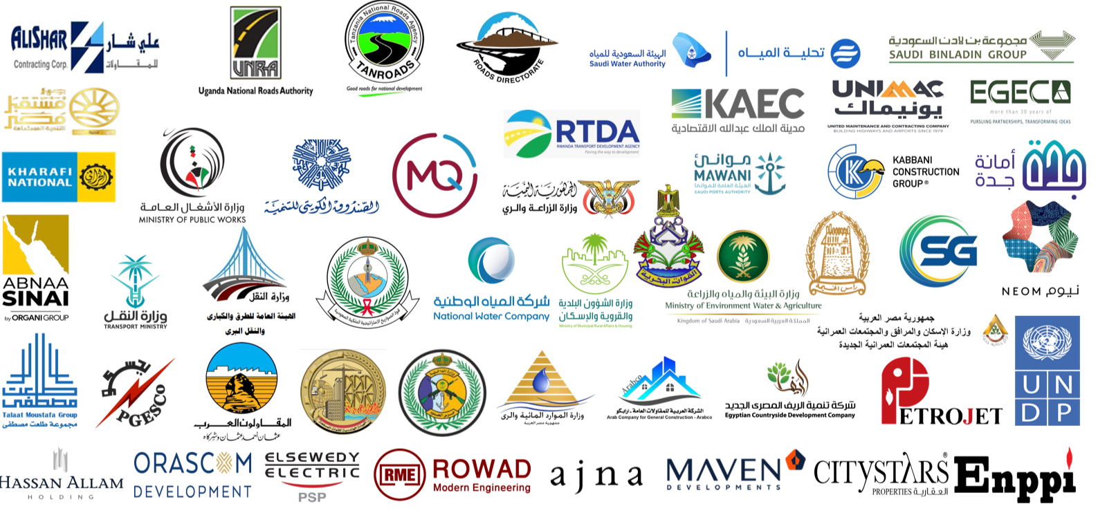
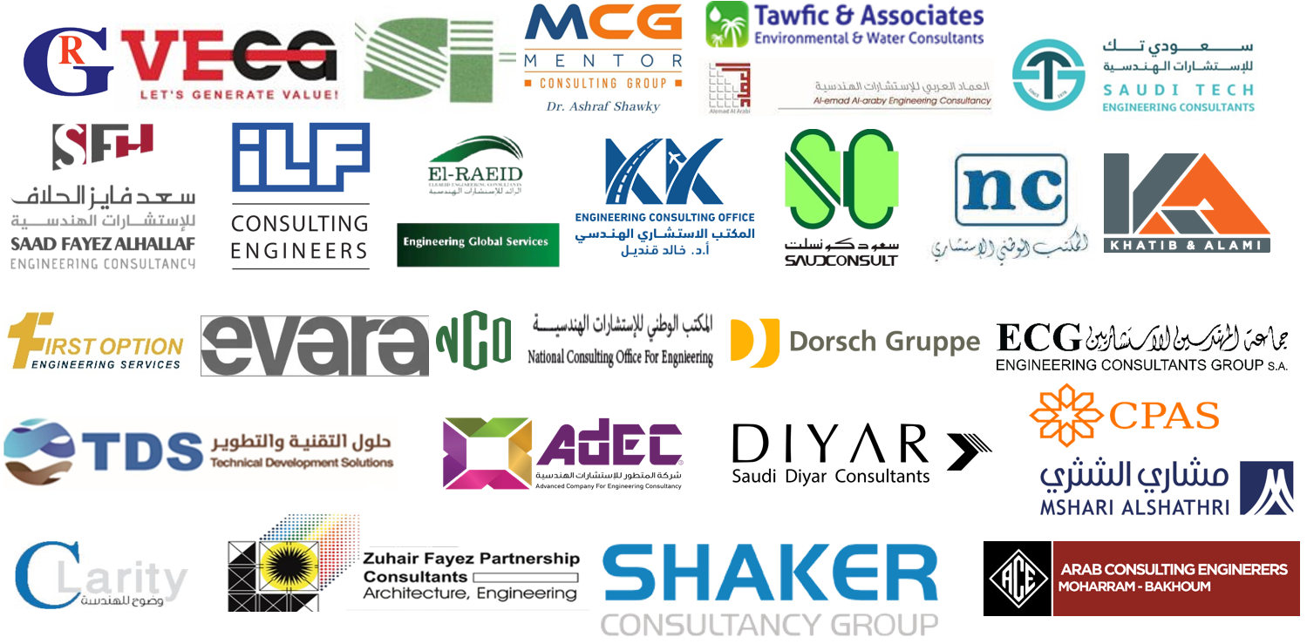

Figure 4 AIEcon’s Partners

Project Scope:
- Initial Review and Scope Definition:
- Review IFC Drawings: Analyze Issued for Construction (IFC) drawings, specifications, and BOQs to understand design intent.
- Identify Drawing Packages
- Define Scope: Clarify which elements require shop drawings (e.g., manholes, pipe networks, etc).
- Shop Drawing Development
- Plan and Profile Drawings:
- Detailed Component Drawings:
- Manholes, chambers, gullies, valve boxes, thrust blocks.
- Coordination Drawings:
- Composite utility plans to resolve clashes.
- Cross-sectional views showing multi-utility corridors.
- Internal QA/QC and Coordination:
- Technical Review:
- Check compliance with codes (e.g., Egyptian Code, AASHTO, BS).
- Verify hydraulic and structural calculations if applicable.
- Clash Detection:
- Use Civil 3D, Navisworks, or BIM tools to detect and resolve conflicts.
- Interdisciplinary Coordination:
- Align with architectural, structural, MEP, and landscape drawings.
- Submission and Review Process:
- Transmittal Preparation:
- Include drawing register, revision history, and compliance checklist.
- Submission to Consultant/Client:
- Submit in required formats (PDF, DWG) with clear revision clouds and notes.
- Comment Resolution:
- Log comments, respond technically, and revise drawings accordingly.
- Maintain a comment resolution matrix for traceability.
- Final Approval and Issuance:
- Incorporate Final Comments: Ensure all feedback is addressed.
- Stamp and Archive: Mark drawings as “Approved for Construction” and store in the document control system.
- Distribute to Site Teams: Ensure the latest versions are available to execution teams.

BIM Methodology (Optional)
LOD 400 – Fabrication and Construction:
This level supports actual construction and prefabrication. Models are highly detailed and include fabrication, installation, and assembly information.
Key Components:
  - Precise fabrication details: Reinforcement layouts, formwork, asphalt mix designs, precast elements.
  - Construction sequencing: 4D BIM integration with project schedules.
  - Cost estimation: 5D BIM for quantity take-offs and budget tracking.
  - Field-ready deliverables: Shop drawings, installation guides, and equipment specs.

AIEConLLC

